Addis Ababa University
Science Faculty
Mathematics Department
Math 231B: Applied Mathematics I
Final Examination

Date: March 2, 2008
Time allowed: 3hrs

Name: ______________________________________ ID. No. _____________________

Department: _________________________________

Instructions: This examination has two parts. Part I has 20 short answer questions worth 3 points each to be answered in the blank spaces following each question and sub-question. Part II, worth a total of 40 points, has 5 workout problems, each problem allotted the points shown against it. Show all necessary steps and write with ink clearly in the spaces provided for each problem.

Make sure that your exam paper has 9 pages

For instructor’s use only

Part I | Part II |  |  |  |  | Total
Part I | 1 | 2 | 3 | 4 | 5 | Total

Part I Short answer questions

- If v = ⟨x, 2, 1 ⟩ and w = ⟨1, 0, -1⟩ are orthogonal vectors then x = ___________________
- If v = ⟨ 1, 1, 0 ⟩ and w = ⟨ , 2,  ⟩ then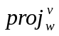 = ___________________________
- If the angle between v = a_{i} + j + k and the x – axis is 60⁰ then a = ______________
- If v = i – j + k and w = -i + 2j the two vectors orthogonal to both v and w are ________________________ and _________________________.
- The equation of the plane passing through (0, 0, 0) and perpendicular to the line
L: ⟨1, 0, 1⟩ + t ⟨1, 2, -3⟩ is _____________________________
- The rank of A = 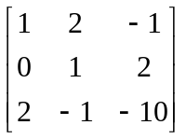 is _________________________________
- If A = 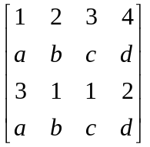 then
    - det A = ____________ for all a, b, c, d, ∈ ℜ
b) what can be said about A⁻¹? ____________________________
- If det A = 3 then det (AA^{t} A⁻¹)² = _________________________________
- The homogeneous linear system
3x₁ – x₂ + 2x₃ = 0
ax₁ + 4x₂ + 5x₃ = 0
3x₁ – x₂ + 3x₃ = 0
has a unique solution if a = _______________________
- If A = 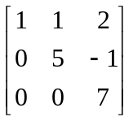 then
    - the characteristic polynomial of A is __________________
    - the eigenvalue(s) of A ____________________
- a) 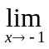(x² – 2x + 1) = ______________________
b) 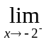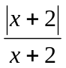 = _____________________
- a) 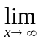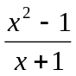 = _______________________
b) x sin
- a) 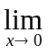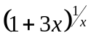 = __________________________________
b) 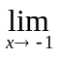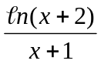= __________________________________
- If f(x) = 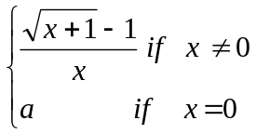 then f is continuous at x = 0 if a = __________________
- a) If f(x) = n (cosh2x)) then
- ƒ′(x) = ________________________
  - ƒ′′(x) = ________________________
- If f(x) = tan⁻¹x² then
  - ƒ′(x) = __________________
ii) ƒ′(1) = __________________
- If x²y + xy² = 2x³ then
    - y′ = __________________
    - y′′ = __________________
- If f(x) = x³ + 1,
    - the equation of the tangent line to the graph of f at (0, 1) is __________________
    - the equation of the normal line to the graph of f at (0, 1) is __________________

- If f(x) = x² – 1, x ∈ [1, 2] then
a) f_{min} = ___________________ b) f_{max} = _____________________
19. a) 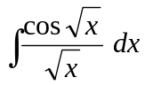= ________________
b) 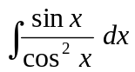 = __________________
20. a) 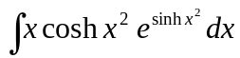 = ___________________________
b) 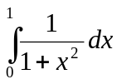= _________________________________
Part II Workout problems

1. The equations of π₁ and π₂ are given in (a) and (b) below. In each case, determine whether
i) π₁ and π₂ are parallel or intersecting
ii) If parallel find the distance between them; if intersecting, find the angle between, them
- π₁: x + 2y – 3z -2 = 0; π₂: -2x – 4y + 6z = 6

- π₁: 3x + y + z = 0; π₂: x – 4y + z – 5 = 0
(7 points)

- Solve the following system of linear equations using Cramer’s Rule. (6 points)
-2x₁ + x₂ + x₃ = 2
x₁ – 2x₂ – x₃ = -1
3x₁ + x₂ – 2x₃ = 1

- a) Use the definition of the derivative to find ƒ′(x) where f(x) = x² + x.

  - Show that f defined by f(x) = |x³ – 1| is not differential at x = 1
(7 points)

- Sketch the graph of y = 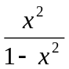 (11 points)

- Evaluate each of the following integrals (9 points)
a) 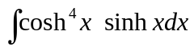

b) 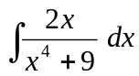

c) 